TestCase1:

Set up a HelpDeskOMT to be the alternate destination for PAR.
Set up FCB OMT for the firm you are using to be HOMT1.
In this example, W001 is the PAR workstation and HOMT1 is the Help desk/Alternate OMT.
Login to the Help Desk OMT
Do not login to the PAR (W001) and route an order.
You should see the order routed to HOMT1.

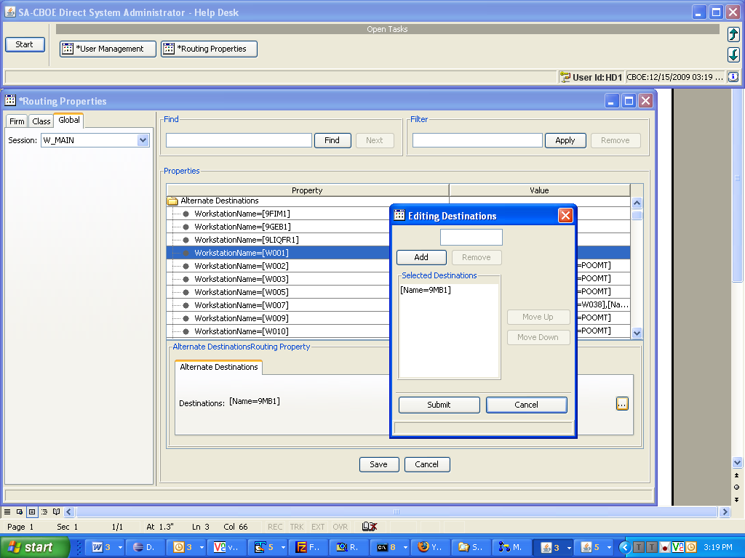
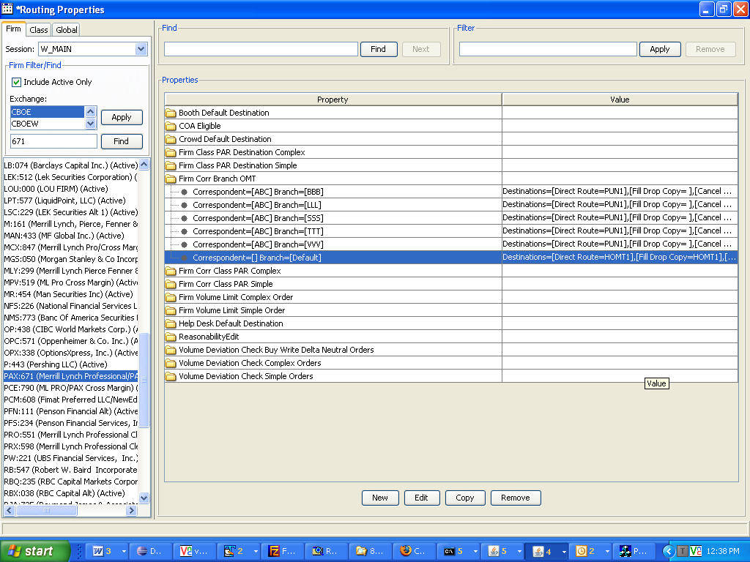
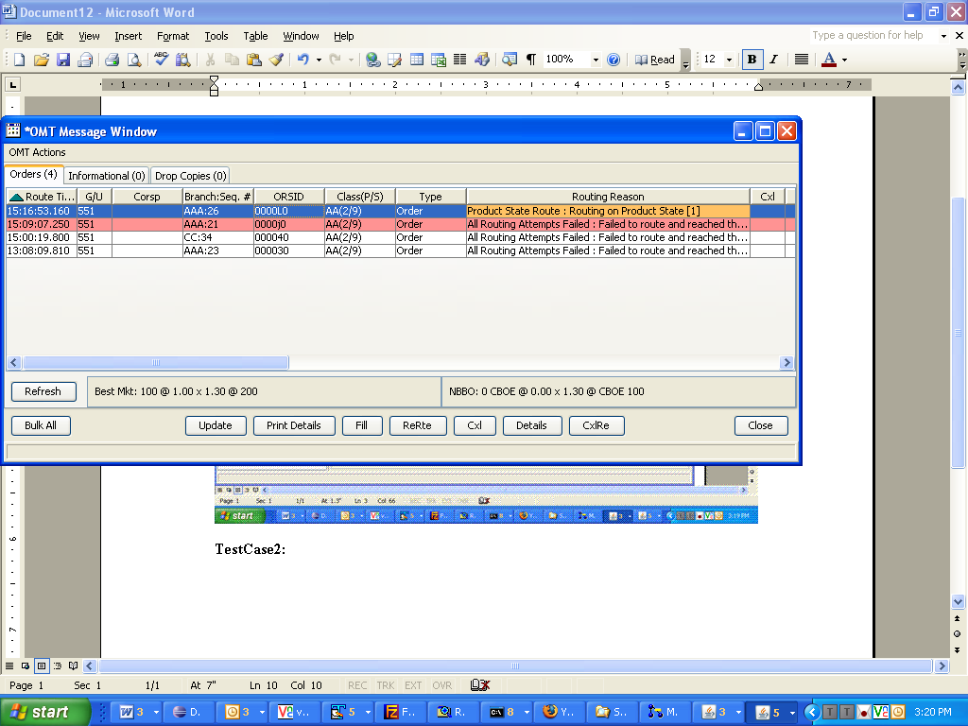

TestCase2:
Logout from that OMT.
Logout from the PAR.
Route an order to that PAR.
Log back into that OMT.
You should see the order in that OMT.
